What is Flume?

Apache Flume is a tool/service/data ingestion mechanism for collecting aggregating and transporting large amounts of streaming data such as log files, events (etc...) from various sources to a centralized data store

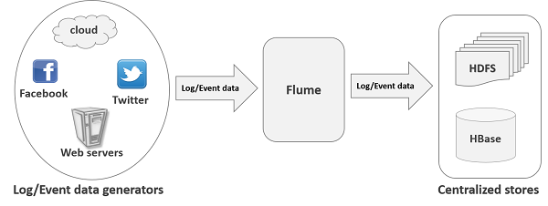

components

### Source

A **source** is the component of an Agent which receives data from the data generators and transfers it to one or more channels in the form of Flume events.

Apache Flume supports several types of sources and each source receives events from a specified data generator.

**Example** − Avro source, Thrift source, twitter 1% source etc.

### Channel

A **channel** is a transient store which receives the events from the source and buffers them till they are consumed by sinks. It acts as a bridge between the sources and the sinks.

These channels are fully transactional and they can work with any number of sources and sinks.

**Example** − JDBC channel, File system channel, Memory channel, etc.

### Sink

A **sink** stores the data into centralized stores like HBase and HDFS. It consumes the data (events) from the channels and delivers it to the destination. The destination of the sink might be another agent or the central stores.

**Example** − HDFS sink

